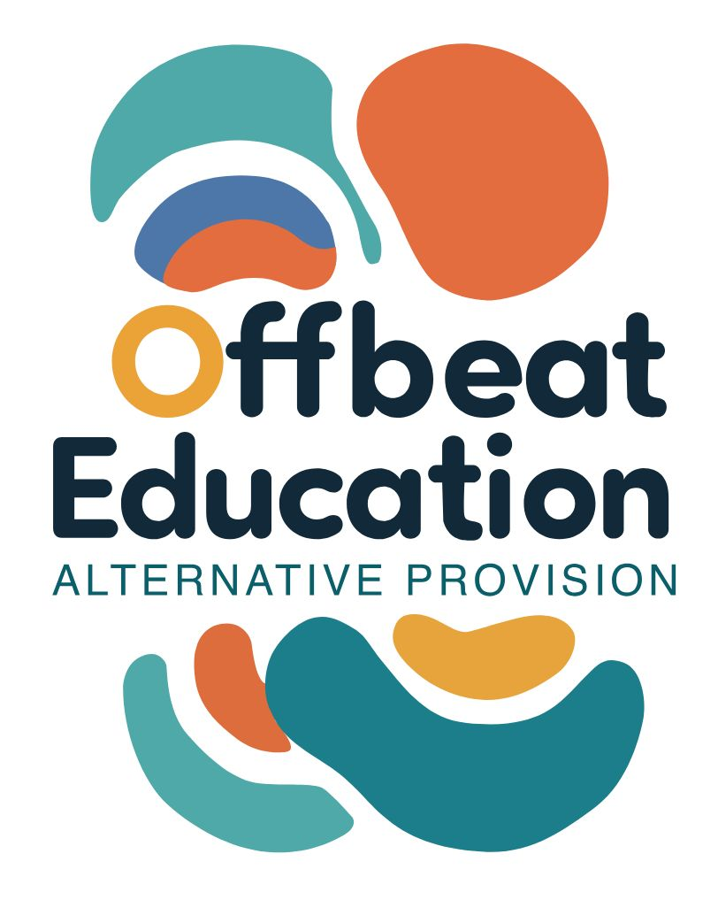

Offbeat Education

GDPR and Data Protection Policy

Policy Details

Date Published: | 29.11.25 | Version Number: | 1
Date of Next Review: | 29.11.26
Individual Responsible for Policy: |  | Toni Doherty

Purpose
This policy outlines how Offbeat Education collects, uses, stores, shares and protects personal data in compliance with the UK General Data Protection Regulation (UK GDPR) and the Data Protection Act 2018. Offbeat Education is committed to protecting the rights, freedoms and privacy of all individuals whose data we process, particularly children, young people and vulnerable learners.
Scope
This policy applies to:
- All staff, volunteers, and contractors
- Learners and their families
- Visitors and external partners
- Any individual whose data is processed by Offbeat Education
Key Data Protection Principles
Offbeat Education processes personal data in accordance with the following UK GDPR principles:
- Lawfulness, fairness and transparency
- Purpose limitation
- Data minimisation
- Accuracy
- Storage limitation
- Integrity and confidentiality
- Accountability

Roles of Data Controller and Data Processor
Where Offbeat Education delivers services directly, it acts as a Data Controller.
Where Offbeat Education delivers services on behalf of a local authority, including Suffolk County Council, the local authority acts as the Data Controller and Offbeat Education acts as the Data Processor. In these circumstances, personal data is processed strictly in accordance with the Data Controller’s written instructions and contractual requirements.
Types of Personal Data Processed
Offbeat Education may collect and process the following categories of data:
- Learner information (name, date of birth, Unique Learner Number)
- Special Educational Needs (SEN) and EHCP-related information
- Safeguarding and child protection records
- Attendance, behaviour, progress and assessment data
- Parent and carer contact details
- Health and medical information relevant to learning or safeguarding
- Staff employment and safeguarding records
- CCTV footage (where applicable)
Special category data is processed only where necessary and with appropriate safeguards in place.

Lawful Bases for Processing
Personal data is processed under one or more of the following lawful bases:
- Legal obligation (e.g. safeguarding duties, education law)
- Public task (delivery of education and training)
- Consent (e.g. photography, marketing)
- Legitimate interests (e.g. staff wellbeing, organisational security)

Data Security
Offbeat Education implements appropriate technical and organisational measures, including:
- Password-protected systems and role-based access controls
- Secure cloud-based storage compliant with UK GDPR
- Encryption of devices where appropriate
- Locked storage for paper records
- Regular data protection and safeguarding training for staff
- Clear desk and clear screen practices

Data Sharing
Personal data may be shared with:
- Local authorities and safeguarding partners
- Awarding bodies, including NOCN, for learner registration, assessment and certification
- Health and social care professionals
- Law enforcement agencies where legally required
- Third-party service providers under formal data processing agreements
Offbeat Education does not sell personal data.

Data Retention and Disposal
Personal data is retained only for as long as necessary to meet legal, contractual, safeguarding and awarding body requirements. Data is securely deleted or returned at the end of retention periods or upon contract termination, in line with local authority instructions.
Data Subject Rights
Individuals have the right to:
- Access their personal data
- Request rectification or erasure
- Restrict or object to processing
- Data portability (where applicable)
- Withdraw consent (where consent is the lawful basis)
Requests should be submitted in writing to the Data Protection Lead.

Data Breaches
All data breaches must be reported immediately to the Data Protection Lead.
Where Offbeat Education acts as a Data Processor for a local authority, any personal data breach will be reported to the authority without undue delay and no later than 24 hours after identification. Breaches will be reported to the Information Commissioner’s Office (ICO) within 72 hours where required.

Training and Awareness
All staff are required to complete annual data protection and safeguarding training and to comply fully with this policy.
Policy Review
This policy is reviewed annually or in response to changes in legislation, contractual requirements or data processing activities.

- Version History

Version | Date Published | Changes Made | Signed off by

