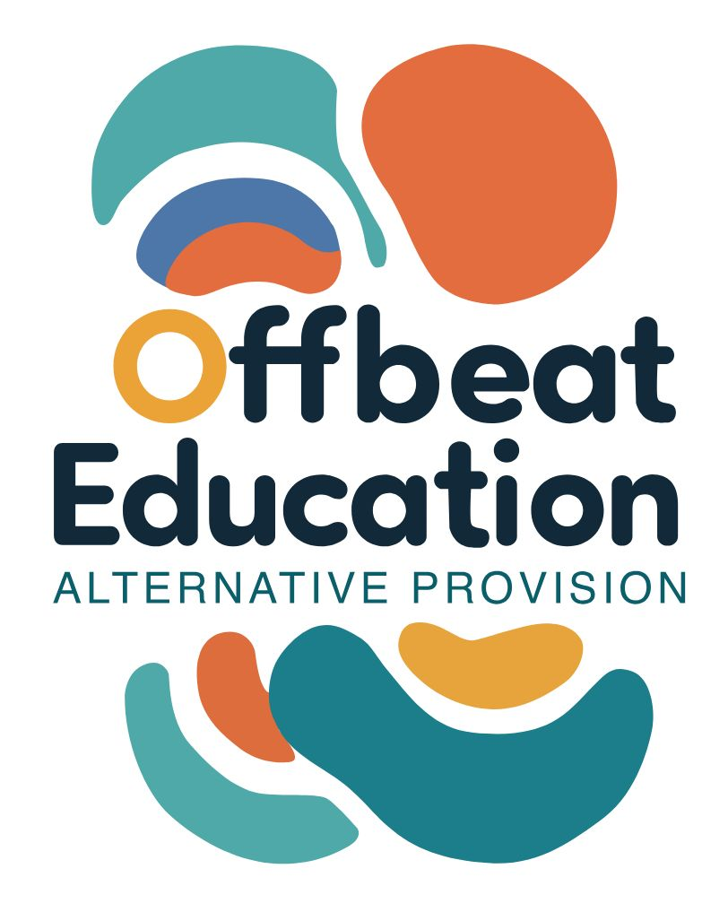

Offbeat Education

Relationships and Sex Education (RSE) Policy

Policy Details

Date Published: | 30.11.25 | Version Number: | 1
Date of Next Review: | 30.11.26
Individual Responsible for Policy: |  | Toni Doherty

Purpose
This policy outlines Offbeat Education’s approach to delivering Relationships and Sex Education (RSE). Our aim is to equip learners with the knowledge, skills, and values to develop healthy, respectful relationships and make informed decisions about their wellbeing, sexuality, and safety.
Legal Framework
This policy is based on:
- Relationships Education, Relationships and Sex Education and Health Education Statutory Guidance (DfE, 2019, updated 2025)
- Children and Social Work Act 2017
- Equality Act 2010
- Keeping Children Safe in Education (KCSIE) 2025
- SEND Code of Practice 2015
Scope
RSE is a statutory requirement for all secondary-aged pupils. At Offbeat Education, we deliver RSE to all learners in Key Stages 3, 4 and 5 including those with special educational needs and those receiving part-time or bespoke education packages.
Our curriculum is age-appropriate, inclusive, and learner-led. It includes:
Relationships
- Building respectful friendships and partnerships
- Understanding boundaries, consent, and communication
- Navigating peer pressure, conflict, and emotional wellbeing
- Exploring different types of relationships (romantic, platonic, familial)
Sex Education
- Understanding puberty, reproduction, and body autonomy
- Exploring sexual orientation, gender identity, and expression
- Learning about contraception, STIs, and sexual health services
- Discussing pleasure, safety, and informed decision-making
Digital Relationships
- Online safety, sexting, and digital consent
- Managing social media and online interactions
- Recognising and responding to online abuse or exploitation
Teaching Approach
We use creative, inclusive, and participatory methods:
- Art, music, storytelling, and role-play
- Group discussions, reflective journaling, and learner-led projects
- Workshops with health professionals, artists, and peer educators
- Trauma-informed facilitation and opt-in participation
Safeguarding and Confidentiality
- All sessions are delivered in line with our safeguarding policy
- Learners are informed about the limits of confidentiality
- Disclosures of harm or abuse are taken seriously and followed up appropriately
Inclusivity and Accessibility
We ensure:
- Representation of diverse bodies, identities, and experiences
- Materials are accessible to neurodiverse learners and those with additional needs
- Language is inclusive, non-judgmental, and affirming
Family and Community Engagement
- Parents/carers are informed about the curriculum and invited to contribute
- We provide resources and guidance to support conversations at home
- We respect the right to withdraw from sex education (not relationships education), in line with statutory guidance
Monitoring and Evaluation
- Learner feedback is central to shaping and improving our provision
- Staff receive regular training and support
- The policy is reviewed biennially with input from learners, staff, and stakeholders

- Version History

Version | Date Published | Changes Made | Signed off by

