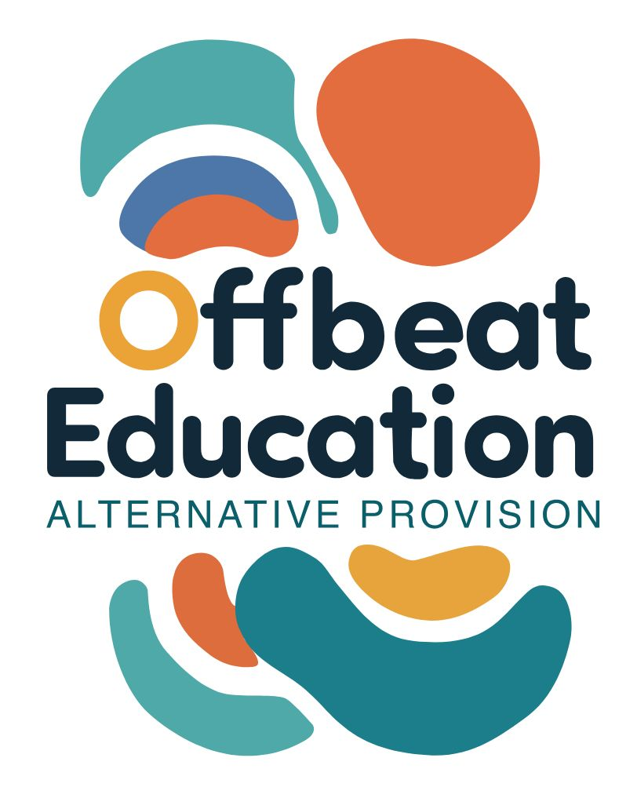

Offbeat Education

SEND Policy

Policy Details

Date Published: | 17.12.25 | Version Number: | 1
Date of Next Review: | 17.12.26
Individual Responsible for Policy: |  | Tory Laudham

Offbeat Education

Special Educational Needs and Disabilities (SEND) Policy

1. Policy Statement

Offbeat Education is committed to providing inclusive, person-centred education for children and young people with Special Educational Needs and Disabilities (SEND). We believe that all learners have strengths, capabilities and the right to access high-quality education that meets their individual needs.

Our practice is rooted in relational, trauma-informed approaches and is aligned with the SEND Code of Practice (2015), the Equality Act (2010), and relevant local authority expectations, including Suffolk County Council.

2. Scope

This policy applies to:

- All learners accessing Offbeat Education provision
- All staff, tutors, volunteers and contractors
- Provision delivered under:

- NOCN Functional Skills English and Maths
- Pathway to Adulthood Programme
- Bespoke and alternative provision

3. Aims

We aim to:

- Identify and support SEND early and effectively
- Remove barriers to learning and participation
- Promote positive wellbeing, engagement and progress
- Work in partnership with learners, parents/carers and professionals
- Enable learners to develop confidence, independence and preparation for adulthood

4. Definition of SEND

A learner has SEND if they have a learning difficulty or disability which calls for special educational provision to be made for them, as defined in the SEND Code of Practice (2015).

This may include difficulties related to:

- Cognition and learning
- Communication and interaction
- Social, emotional and mental health (SEMH)
- Sensory and/or physical needs

Identification and Assessment

SEND may be identified through:

- Information from parents/carers or learners
- Local authority referrals or EHCP documentation
- Previous education settings or professionals
- Observation, assessment and review within Offbeat Education

We use ongoing assessment and review to understand each learner’s strengths, needs and preferred ways of learning.

6. Education, Health and Care Plans (EHCPs)

Where a learner has an EHCP, Offbeat Education will:

- Deliver provision in line with agreed outcomes and support strategies
- Contribute to annual reviews and professional reports
- Work collaboratively with the local authority and multi-agency partners
- Ensure learner and parent/carer voice is central to planning and review

7. Teaching and Learning Approaches

We use a flexible and personalised approach, which may include:

- Small group or 1:1 teaching
- Differentiated and scaffolded learning
- Visual supports and structured routines
- Alternative methods of recording and assessment
- Regulation and wellbeing strategies
- Functional, real-life learning contexts

Reasonable adjustments are made to ensure learners can access education on an equitable basis.

8. Partnerships with Parents and Carers

We recognise parents and carers as key partners and will:

- Share information openly and regularly
- Involve parents/carers in planning and review
- Seek and respond to parent/carer feedback
- Provide clear points of contact and support
9. Learner Voice

Learners are encouraged and supported to:

- Share their views, preferences and goals
- Participate in decisions about their learning
- Express their voice in ways that suit them

Learner voice is embedded through reviews, feedback activities and daily interactions.

10. Roles and Responsibilities

SENCO (Tory Laudham)

- Oversee SEND provision and compliance
- Liaise with local authorities and professionals
- Support staff with SEND strategies
- Monitor learner progress and outcomes
All Staff and Tutors:

- Deliver inclusive, differentiated teaching
- Implement agreed support strategies
- Monitor progress and wellbeing
- Raise concerns promptly

11. Safeguarding and Wellbeing

SEND learners may be more vulnerable to safeguarding risks. All staff follow Offbeat Education’s Safeguarding Policy and are trained to recognise and respond to concerns appropriately.

12. Accessibility and Equality

Offbeat Education complies with the **Equality Act (2010)** and does not discriminate on the basis of disability. We make reasonable adjustments to ensure fair access to education and services.

13. Monitoring and Review

This policy is reviewed annually or in response to:

- Changes in legislation or guidance
- Local authority or commissioner requirements
- Feedback from learners, parents/carers or staff

This policy should be read alongside:

- Safeguarding Policy
- GDPR Policy
- Behaviour and Relationships Policy
- Pupil Voice and Parent/Carer Voice Policies

- Version History

Version | Date Published | Changes Made | Signed off by

