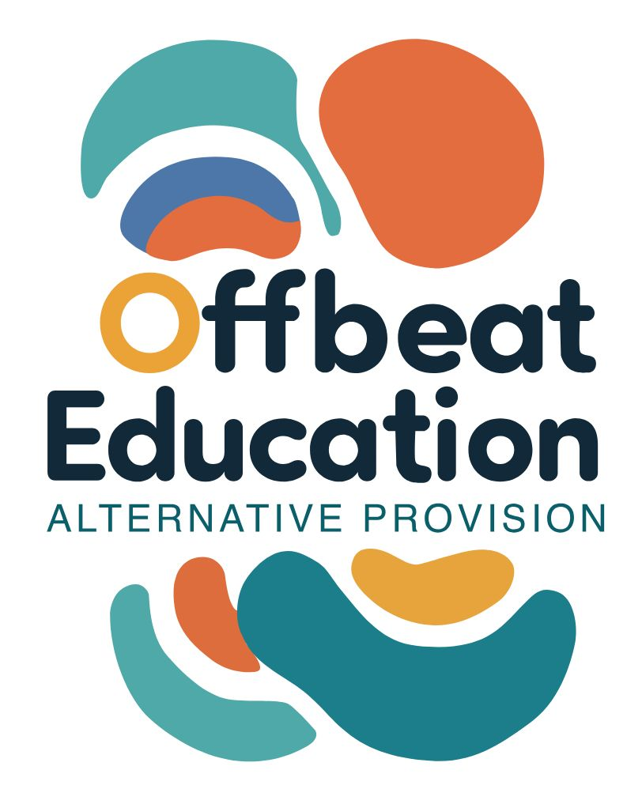

Offbeat Education

Safeguarding and Child Protection Policy

Policy Details

Date Published: | 01.12.25 | Version Number: | 1
Date of Next Review: | 01.12.26
Individual Responsible for Policy: |  | Toni Doherty

Statement of Intent
We are committed to safeguarding and promoting the welfare of all children and young people. Our alternative provision offers a safe, inclusive, and nurturing environment where every learner is respected, valued, and supported to achieve their full potential.
Legal Framework
This policy is based on:
- Keeping Children Safe in Education (KCSIE) 2025 KCSIE 2025
- Working Together to Safeguard Children 2023 Working Together 2023
- Children Act 1989 and 2004 Children Act 1989 and Children Act 2004
- Education Act 2002 Education Act 2002
- The Prevent Duty 2023 Prevent Duty 2023
- SEND Code of Practice 2015 SEND Code of Practice 2015
- Children and Family Act 2014 Children and Family Act 2014
- Local Safeguarding Children Partnership (LSCP) procedure SSP Policy Library
Designated Safeguarding Lead:
Toni Doherty - Director of Wellbeing and Safeguarding
Email toni@offbeat-education.com

Alternate Designated Safeguarding Lead:
Tory Laudham – Director of Inclusion and Education
Email tory@offbeat-education.com

Roles and Responsibilities
All staff are responsible for:
- Being alert to signs of abuse or neglect
- Reporting concerns immediately to the DSL
- Promoting a culture of safety and respect
- Reporting any level of mental health concern, for example but not restricted to; self-harm (actual or intent), suicidal ideation (actual or intent), restricting food or risk-taking behaviours.
Understanding Abuse and Neglect
We recognise:
- Physical, emotional, sexual abuse and neglect
- Contextual risks: CSE, CCE, county lines, radicalisation, online abuse, modern slavery
- Additional vulnerabilities of AP learners (e.g. trauma, SEND, exclusion history)
Safer Recruitment and Staff Conduct
We ensure:
- Enhanced DBS checks for all staff and volunteers
- At least one trained recruiter on every interview panel
- Adherence to our Code of Conduct and Whistleblowing Policy
Training and Induction
- All staff receive annual safeguarding training
- DSLs receive advanced training every 2 years
- New staff complete safeguarding induction before working with learners
Reporting and Recording Concerns
- Concerns must be reported to the DSL immediately
- All concerns are logged securely and confidentially
- We follow LSCP thresholds for referrals to Children’s Social Care
- Our website includes links and guidance for reporting concerns offbeat-education.com
Working with Parents and Agencies
- We engage parents/carers in safeguarding processes where appropriate
- We work in partnership with social workers, police, and health professionals
- We contribute to Early Help, Child in Need, and Child Protection Plans
Online Safety
- We teach digital resilience and safe online behaviour
- Filtering and monitoring systems are in place
- Staff are trained to recognise online risks including grooming and radicalisation

Supporting Vulnerable Learners
We provide tailored support for:
- Children with SEND
- Looked After Children (LAC)
- Previously excluded or at-risk youth
- Those with mental health needs
Policy Links
Please note this safeguarding policy links to other safeguarding based policies including but not restricted to:
- Absconding
- Allegations against staff
- Children Missing from Education
- Code of Conduct
- Drugs and Alcohol
- E-Safety
- Health and Safety
- Safe Touch
- Sexual Harassment
- Smoking, vaping and e-cig

Reporting on near misses
Offbeat Education will report near misses as it may be indicative of wider contributary factors. Lessons learned will be reported as an outcome. Near misses, and their relevance, will also be included in staff training.
Policy Review
This policy is reviewed annually or in response to:
- Legislative changes
- Serious incidents
- Feedback from staff, learners, or external audits

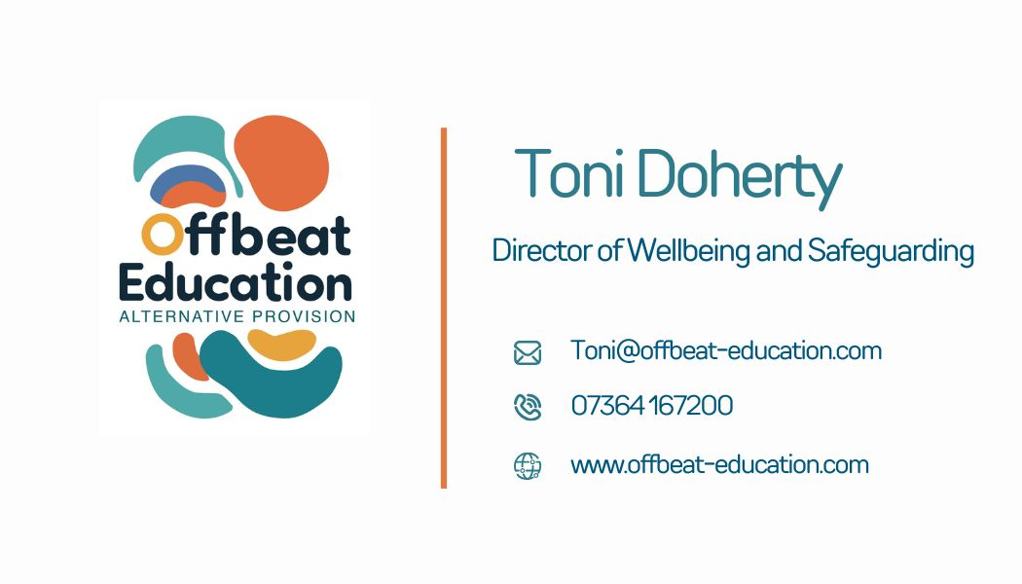

- Version History

Version | Date Published | Changes Made | Signed off by

